MONITORING ONLINE TESTS THROUGH DATA VISUALIZATION

1. Introduction

E-testing systems are widely adopted in academic environments, as well as in combination with other assessment means, providing tutors with powerful tools to submit different types of tests in order to assess learners’ knowledge. Among these, multiple- choice tests are extremely popular, since they can be automatically corrected. However, many learners do not welcome this type of test, because often, it does not let them properly express their capacity, due to the characteristics of multiple-choice questions of being closed-ended. Even many examiners doubt about the real effectiveness of structured tests in assessing learners’ knowledge, and they wonder whether learners are more conditioned by the question type than by its actual difficulty.
In this project, we propose a data exploration approach exploiting information visualization in order to involve tutors in a visual data mining process aiming to detect structures, patterns, and relations between data, which can potentially reveal previously unknown knowledge inherent in tests, such as the test strategies used by the learners, correlations among different questions, and many other aspects, including their impact on the final score .It captures the occurrence of question browsing and answering events by the learners and uses these data to visualize charts containing a chronological review of tests. Other than identifying the most frequently employed strategies, the tutor can determine their effectiveness by correlating their use with the final test scores.

1.1 Existing system

In the existing system, several experiments have been carried out to track learners’ behavior during tests by using the think-out-loud method in which learners were informed of the experiment and had to speak during the test to explain what they were thinking, while an operator was storing their words using a tape recorder.

Disadvantages of existing system
- This technique is quite invasive, since it requires learners to modify their behavior in order to record the information to analyze.
- Complexity of identifying learners’ performance.
- Lack of identifying learners behaviors.

1.2 Proposed System
In the proposed system, we propose a data exploration approach exploiting information visualization. In the proposed system, we present a solution enabling the recording of learner’s habits during online tests without informing learners of the underlying experiment and consequently, without asking them to modify their behavior during tests, this potentially yields more realistic results.
The main goal is to extract the behavioral patterns of the learners and assessing the performance of learner and quality of test. We use data visualization technique to present the results in the form of Pie-charts, Histograms, Bar graphs etc.
Advantages of proposed system

- Presents the clear view of Learners performance using Data Visualization.
- It yields Realistic Results.
- Recording of learners habits during online tests without informing them of the underlying experiment.
===============================================================
Website is been built with html, css, javascript and jsp. DB used is oracle, JDBC is been used to connect with database.

JFreeChart is the only external jars used in this project.

Java Beans are not used in the project, all the DB operations are been performed directly from the JSP pages.

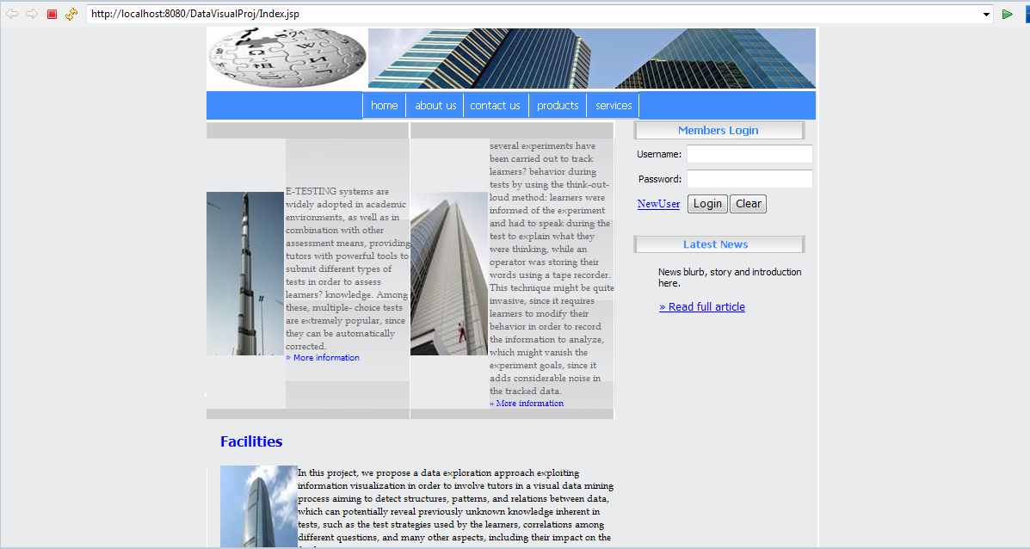
Home page

About us

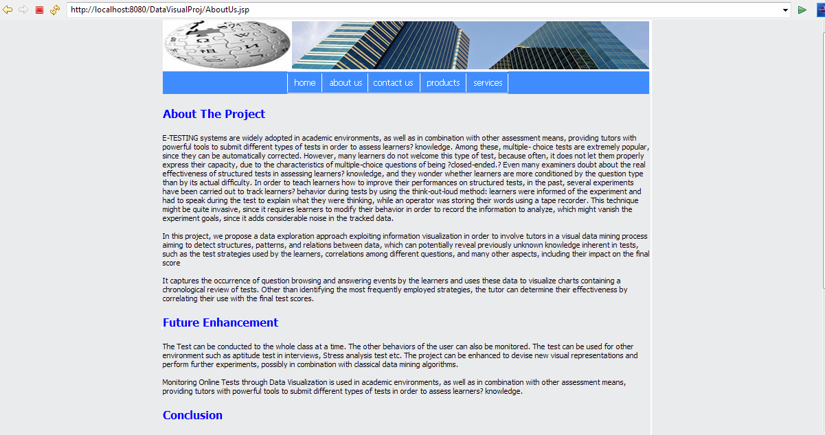

Contact us

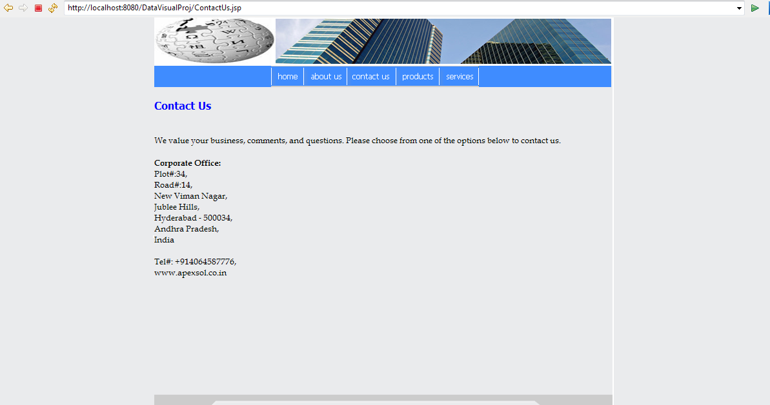

Products

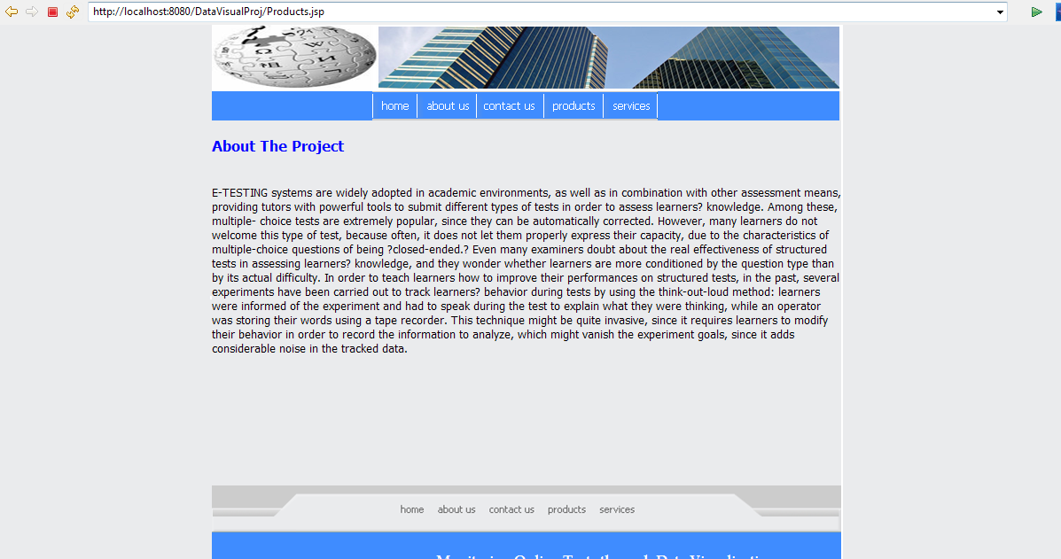

Services

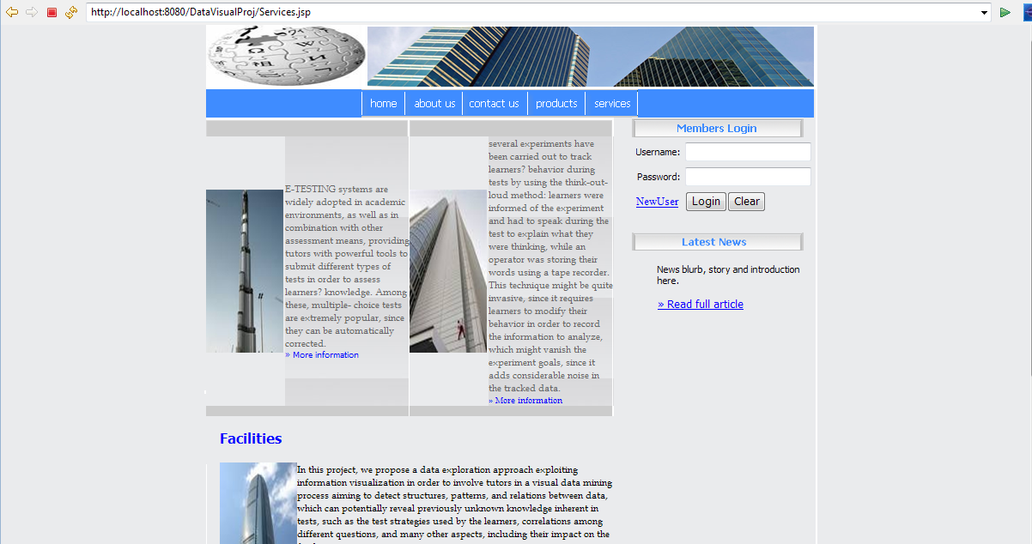

Admin home page

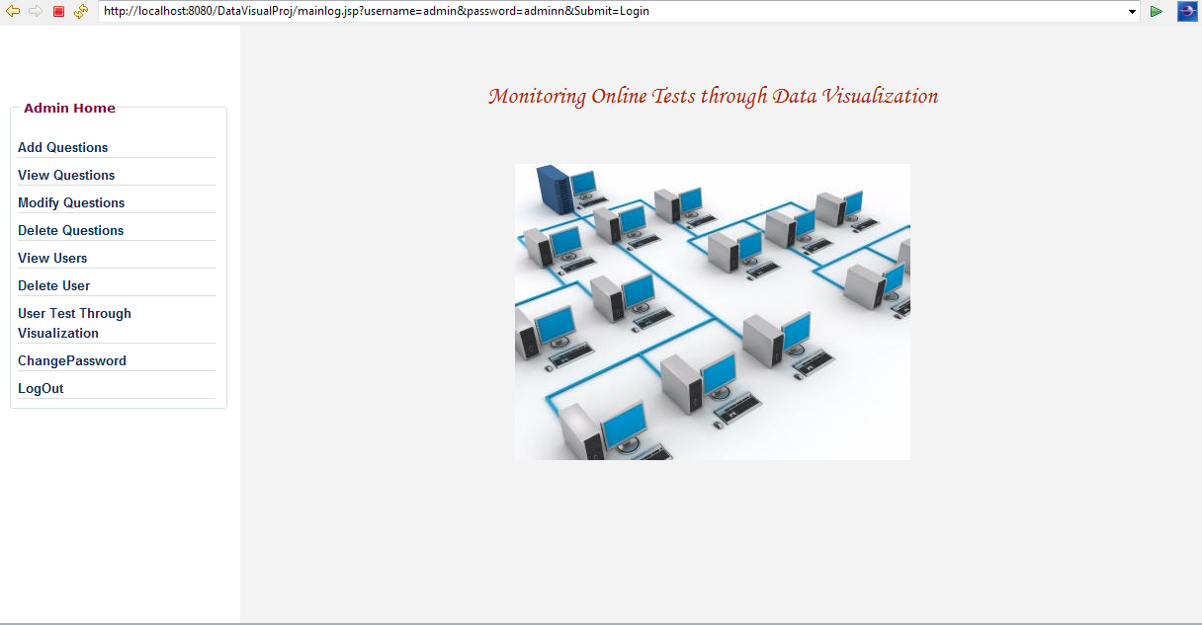

View Questions

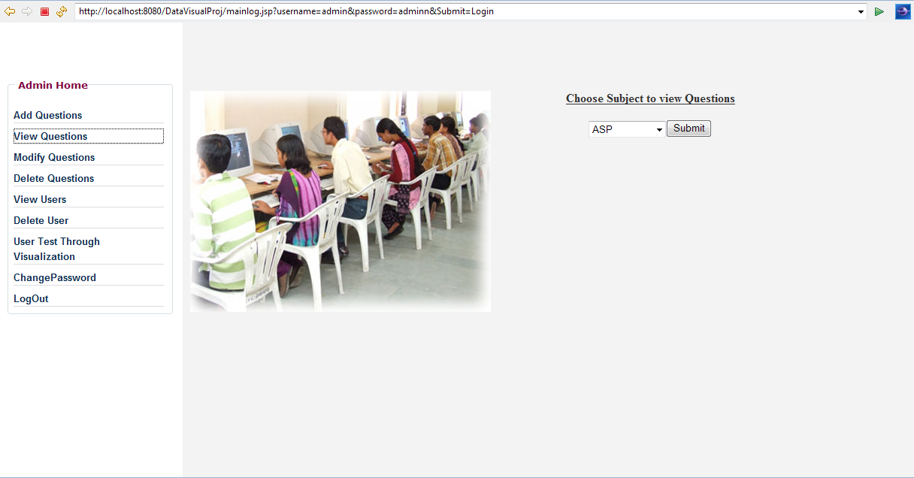

Modify Questions

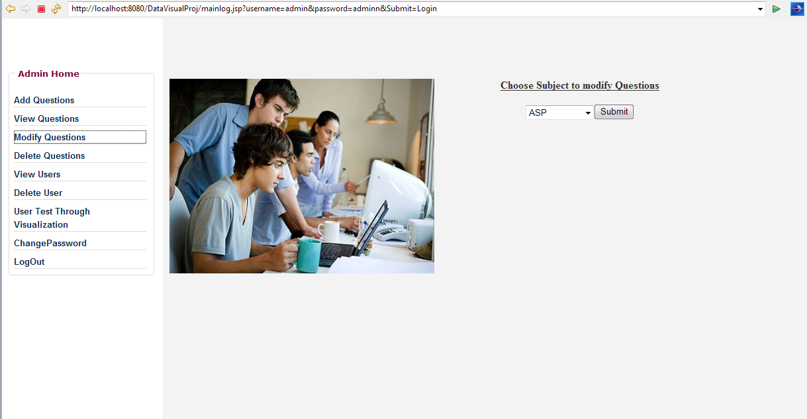

Delete Questions

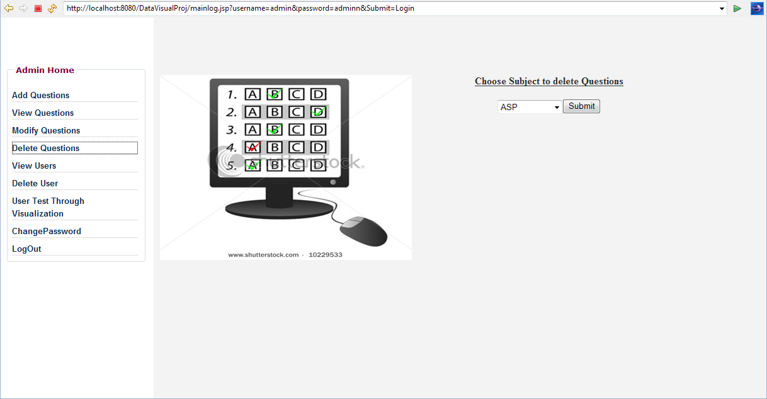

View Users

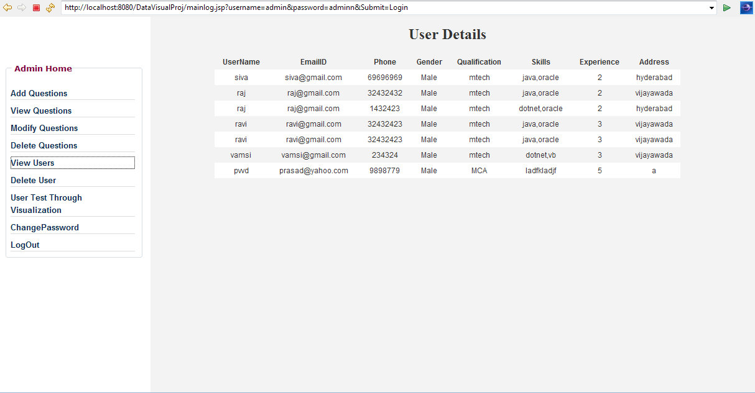

Delete User

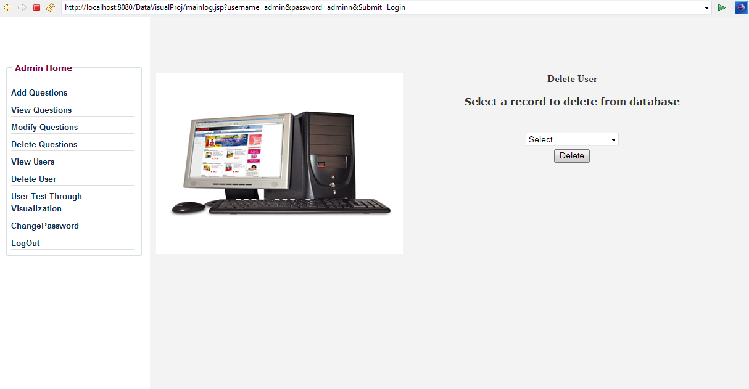

Test Home page

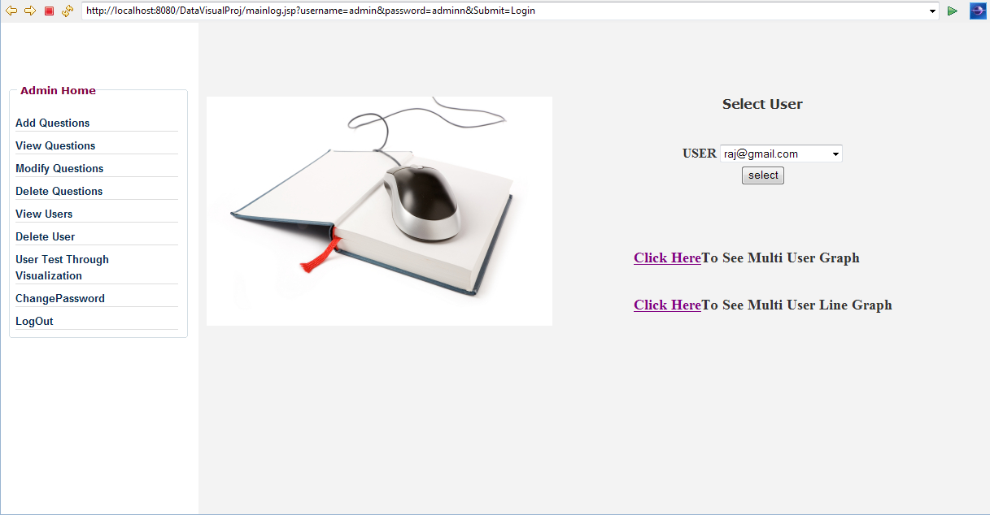

Multi user graph

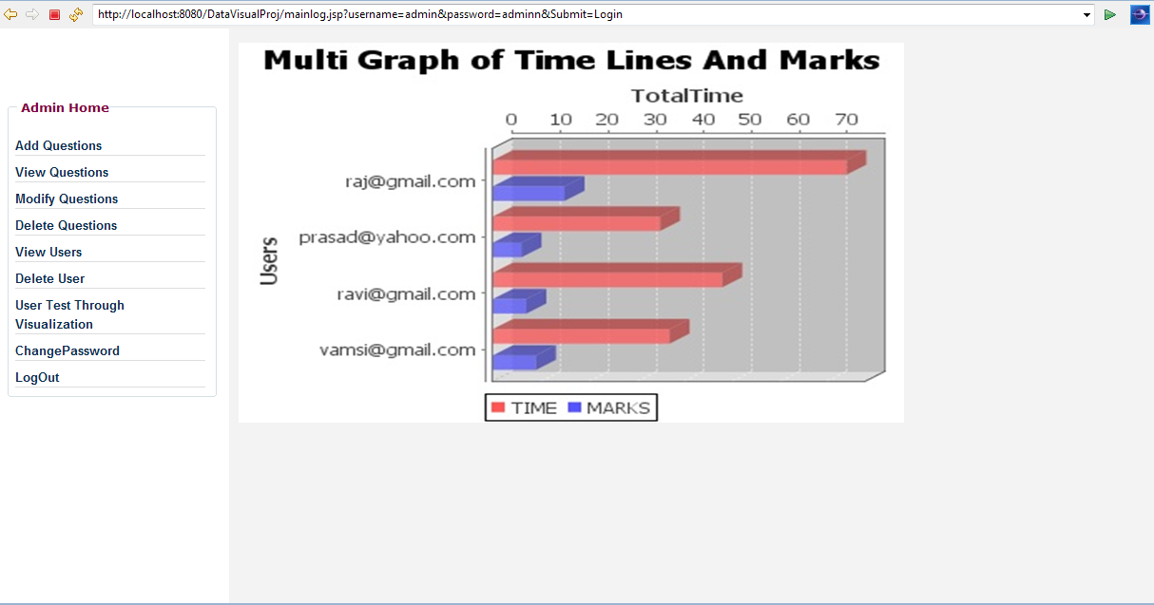

Single user graph

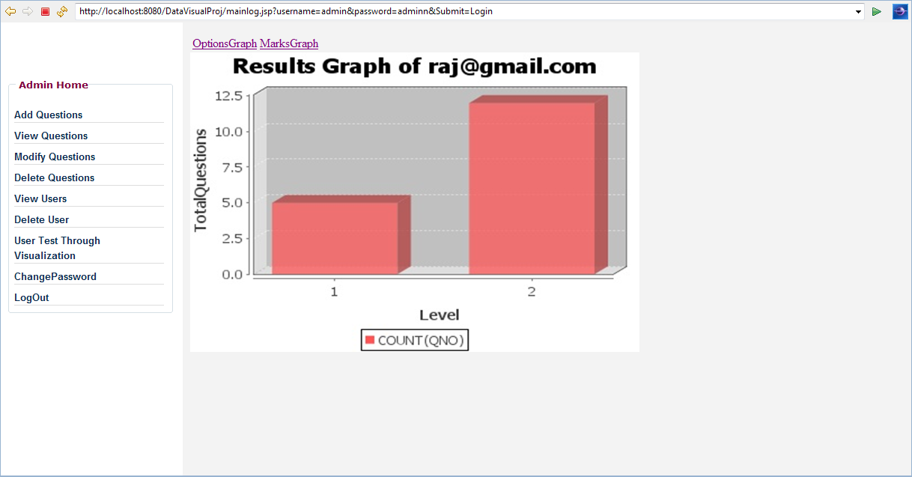

Options graph

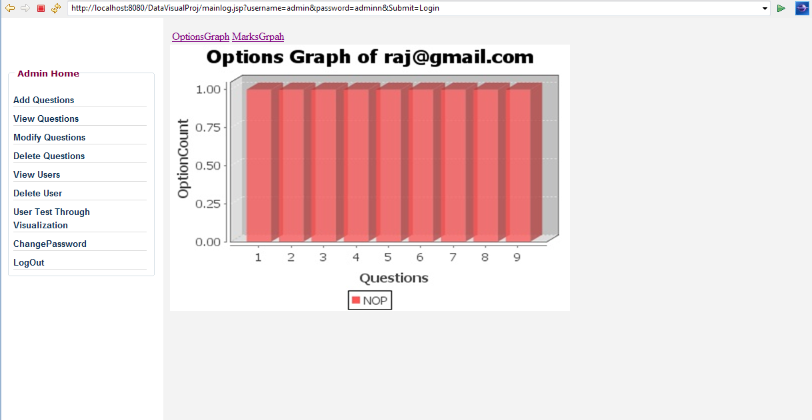

Marks graph

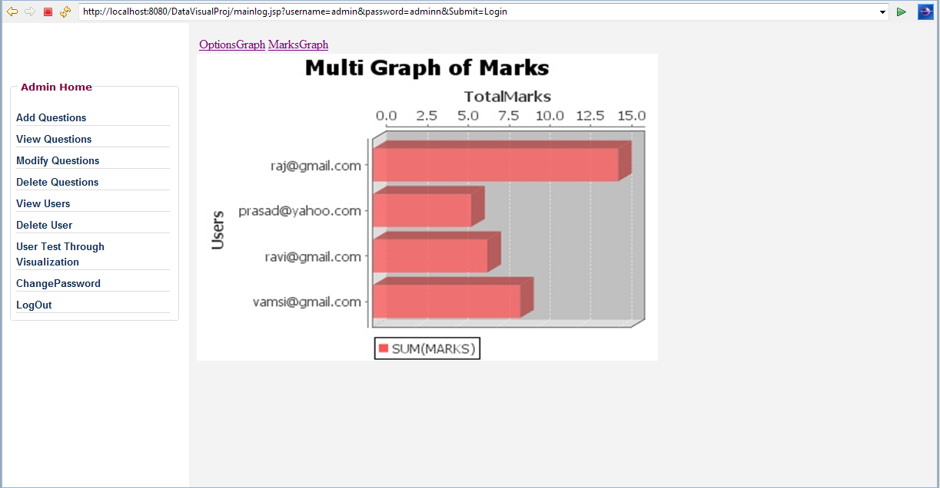

Change password

